**Cathode Ray Tube**

In a cathode ray tube, the "cathode" is a heated filament (not like a filament in bulb). The heated filament is in a vacuum created inside a glass "tube." The "ray" is a stream of electrons that naturally pour off a heated cathode into the vacuum.

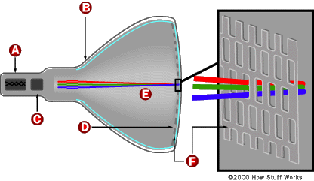

Electrons are negative. The anode is positive, so it attracts the electrons pouring off the cathode. In a TV's cathode ray tube, the stream of electrons is focused by a focusing anode into a tight beam and then accelerated by an accelerating anode. This tight, high-speed beam of electrons flies through the vacuum in the tube and hits the flat screen at the other end of the tube. This screen is coated with phosphor, which glows when struck by the beam.

Electrons are emitted by a cathode heated to a dull red glow, this is a process known as thermionic emission. Positively charged tube components are used to accelerate the electrons away from the cathode, and form them into a beam that will strike a fluorescent screen, converting the electron beam to light, which is visible on the outside of the screen. All of this takes place within the tube envelope which is under high vacuum conditions.  
  
Deflection of the electron beam is necessary to form a pattern on the screen, and there are a couple of ways to do the deflection. In oscilloscopes, it is common to use electrical deflection, which uses a pair of plates on opposite sides of the electron beam. The plates are driven by a voltage (or electrical potential difference) that is proportional to the amount of deflection desired. This sets up an electric field across the region that the electron beam passes through. The field creates a force on the electrons passing through the region, deflecting them from the straight line path that they would normally take.  
  
In oscilloscopes, there are two sets of plates, one set on the "X" coordinate, and one set on the "Y". The "X" plates are usually driven by a saw-tooth waveform that sweeps the electron beam from left to right across the screen surface, making the "X" dimension proportional to time. The "Y" plates are connected to an amplified version of the signal that is desired to display, making the "Y" deflection proportional to the instantaneous voltage of the signal that will be displayed. This creates an "X-Y" display, plotting the signal voltage against time.  
  
In older Cathode Ray Tube (CRT) television sets, the deflection was typically magnetic, using coils surrounding the neck of the CRT, outside of the vacuum envelope, to create the deflection forces.

**Raster Scan**

A **raster scan**, or **raster scanning**, is the rectangular pattern of image capture and reconstruction in television. By analogy, the term is used for raster graphics, the pattern of image storage and transmission used in most computer bitmap image systems. The word *raster* comes from the Latin word *rastrum* (a rake), which is derived from *radere* (to scrape); see also rastrum, an instrument for drawing musical staff lines. The pattern left by the tines of a rake, when drawn straight, resembles the parallel lines of a raster: this line-by-line scanning is what creates a raster. It's a systematic process of covering the area progressively, one line at a time. Although often a great deal faster, it's similar in the most-general sense to how one's gaze travels when one reads English-language text.

**Scan lines**

In a raster scan, an image is subdivided into a sequence of (usually horizontal) strips known as "scan lines". Each scan line can be transmitted in the form of an analog signal as it is read from the video source, as in television systems, or can be further divided into discrete pixels for processing in a computer system. This ordering of pixels by rows is known as raster order, or raster scan order. Analog television has discrete scan lines (discrete vertical resolution), but does *not* have discrete pixels (horizontal resolution) – it instead varies the signal continuously over the scan line. Thus, while the number of scan lines (vertical resolution) is unambiguously defined, the horizontal resolution is more approximate, according to how quickly the signal can change over the course of the scan line.

**Scanning pattern**

[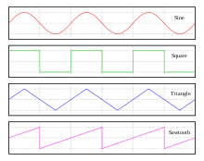](http://en.wikipedia.org/wiki/File:Waveforms.svg)

[http://bits.wikimedia.org/skins-1.17/common/images/magnify-clip.png](http://en.wikipedia.org/wiki/File:Waveforms.svg)

The beam position (sweeps) follow roughly a sawtooth wave.

In raster scanning, the beam sweeps horizontally left-to-right at a steady rate, then blanks and rapidly moves back to the left, where it turns back on and sweeps out the next line. During this time, the vertical position is also steadily increasing (downward), but much more slowly — there is one vertical sweep per image frame, but one horizontal sweep per line of resolution. Thus each scan line is sloped slightly "downhill" (towards the lower right), with a slope of approximately –1/horizontal resolution, while the sweep back to the left (retrace) is significantly faster than the forward scan, and essentially horizontal. The resulting tilt in the scan lines is very small, and is dwarfed in effect by screen convexity and other modest geometrical imperfections.

There is a misconception that once a scan line is complete, a CRT display in effect suddenly jumps internally, by analogy with a typewriter or printer's paper advance or line feed, before creating the next scan line. As discussed above, this does not exactly happen: the vertical sweep continues at a steady rate over a scan line, creating a small tilt. Steady-rate sweep is done, instead of a stair step of advancing every row, because steps are hard to implement technically, while steady-rate is much easier. The resulting tilt is compensated in most CRTs by the tilt and parallelogram adjustments, which impose a small vertical deflection as the beam sweeps across the screen. When properly adjusted, this deflection exactly cancels the downward slope of the scanlines. The horizontal retrace, in turn, slants smoothly downward as the tilt deflection is removed; there's no jump at either end of the retrace. In detail, scanning of CRTs is done by magnetic deflection, by changing the current in the coils of the deflection yoke. Rapidly changing the deflection (a jump) requires a voltage spike to be applied to the yoke, and the deflection can only react as fast as the inductance and spike magnitude permit. Electronically, the inductance of the deflection yoke's vertical windings is relatively high, and thus the current in the yoke, and therefore the vertical part of the magnetic deflection field, can change only slowly.

In fact, spikes *do* occur, both horizontally and vertically, and the corresponding horizontal blanking interval and vertical blanking interval give the deflection currents settle time to retrace and settle to their new value. This happens during the blanking interval.

In electronics, these (usually steady-rate) movements of the beam[s] are called "sweeps", and the circuits that create the currents for the deflection yoke (or voltages for the horizontal deflection plates in an oscilloscope) are called the sweep circuits. These create a saw tooth wave: steady movement across the screen, then a typically rapid move back to the other side, and likewise for the vertical sweep.

Furthermore, wide-deflection-angle CRTs need horizontal sweeps with current that changes proportionally faster toward the center, because the center of the screen is closer to the deflection yoke than the edges. A linear change in current would swing the beams at a constant rate angularly; this would cause horizontal compression toward the center.

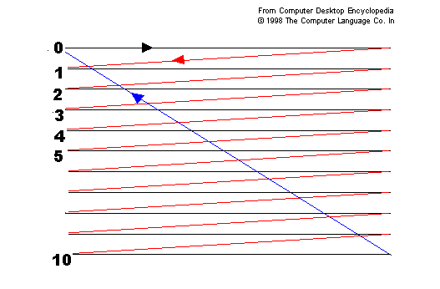

SCANLINE

HORIZONTAL

RETRACE

VERTICAL

RETRACE

**Random Scan**

In a Random scan system, also called vector, stoke writing, or calligraphic the electron beam directly draws the picture. Here the electron gun of a CRT illuminates points and / or straight lines in any order. The display processor repeatedly reads a variable ‘display file’ defining a sequence of X,Y coordinates the electron gun the whole display area is updated many times a second from image data held in raster memory.

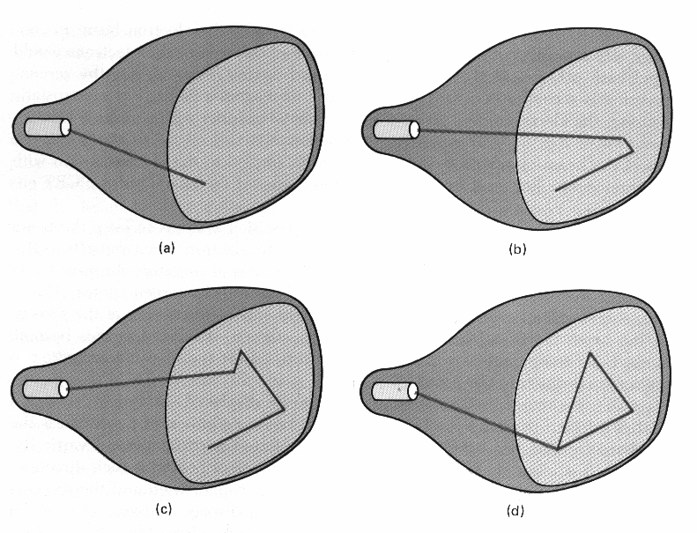

Random Scan Display

# Advantages of random scan:

# Very high resolution, limited only by monitor.

# Easy animation, just draw at different position.

# Requires little memory.

# Disadvantages of random scan:

# Requires “intelligent electron beam, i.e., processor controlled.

# Limited screen density before have flicker, can’t draw a complex image.

# Limited color capability

# Difference between raster scan and random scan technique

## Raster-scan system:-

1)raster displays have less resolution.  
2)the lines producced are ziz-zag as the plotted values are discrete.  
3)high degree realism is achived in picture with the aid of advanced shading and hidden surface technique.  
4)decreasing memory costs have made raster systems popular.

## Random scan system:-

1)random displays have high resolutions since the picture definition is stored as a set of line drawing commands and not as a set of intensity values.  
2)smooth lines are produced as the electron beam directly follows the line path.  
3)realism is difficult to achieve.  
4)random-scan system's are generally costlier.